**State, National & Global Apps**

Apps are customizable by state/region, national, and global coordinators. Coordinators load and maintains resource link databases for state/region, national and global apps that are requested, utilized, or essential to inform and/or facilitate communication, research, programs, initiatives, and responses. Coordinators also update news and maintain apps.

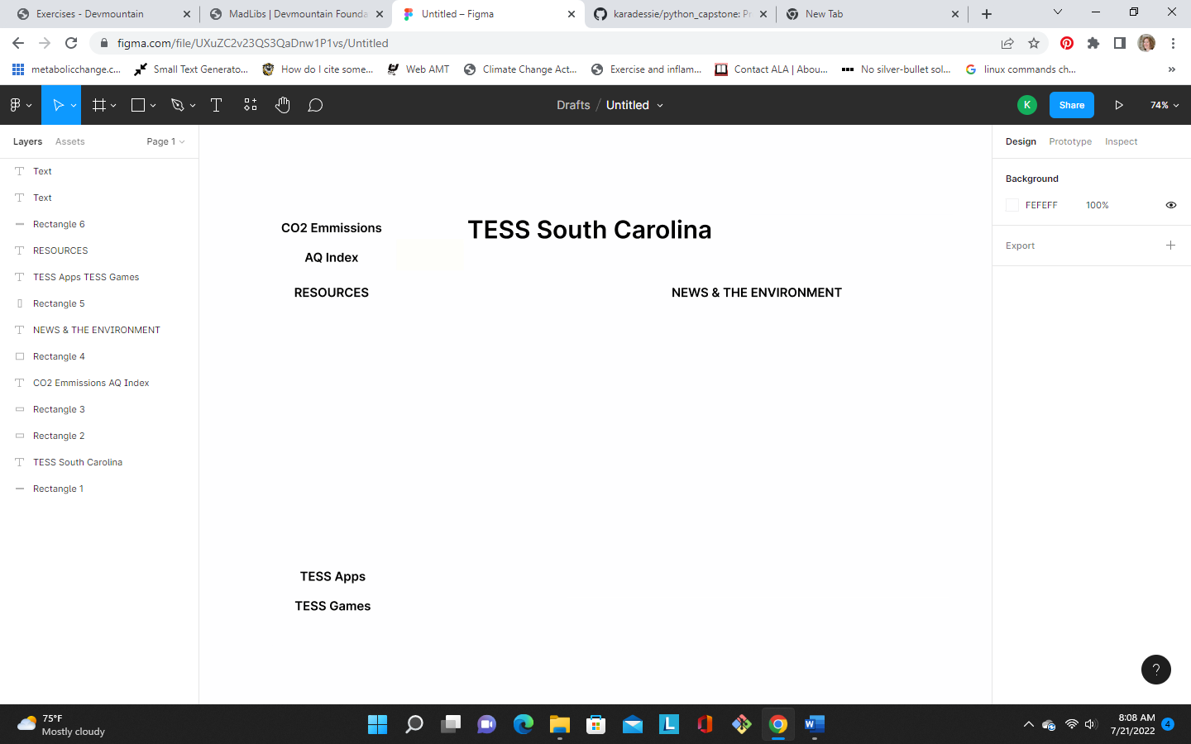Background: FEFEFF, TESS text: 214761, logo image courtesy of Pixabay